ILS has been a popular tool used by a growing number of insurers and reinsurers who buy collateralized protections against losses on peak risks from capital markets rather than the traditional reinsurance market. Sponsors of ILS include large insurance and reinsurance companies, government entities with concentrated and large exposure to tail risks, such as natural disasters, extreme mortalities and other insurance related risks.

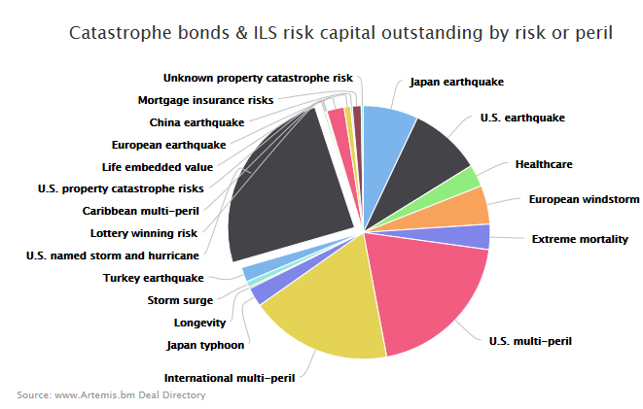

**Figure:** Catastrophe bonds & ILS risk capital outstanding by risk or peril (Artemis.bm)

In 2010, the first catastrophe bond to securitize health insurance was issued for Aetna Life Insurance Co to transfer the risks of **medical benefit claims exceeding pre-defined attachment points**. The special purpose vehicle, Vitality Re issued two tranches notes to ILS investors to provide excess of loss reinsurance agreements. As of January 2016, Aetna has entered into seven Vitality deals to mitigate extreme pandemic risks. Following the trend that is developing rapidly, the client company could consider issuing a catastrophe bond to seek protection on a reinsurance basis against a sudden and/or sharp rise in medical benefit claims and further free up its capital.

More on Vitality Re:

Summary:

Issuer/SPV: Vitality Re VII (Series 2016-1). Note this is the latest one

Cedent/Sponsor: Aetna

Placement/Structuring agent: Goldman Sachs, Munich Re

Risk modelling/calculation agents: Milliman

Risk/Perils covered: Medical benefit claims levels

Size: $200mn

Trigger type: Medical benefit ratios (indemnity)

Ratings: S&P Class A- ‘BBB+(sf), Class B – ‘BB+(sf)’

Date of issue: Jan 2016 – latest

Atena will enter into a quota share agreement with its Health Re captive reinsurance company, which will in turn enter into excess of loss reinsurance agreements with the Vitality Re VII vehicle and Vitality Re will see two tranches of notes to ILS investors to collateralize those reinsurance agreements.

The transaction will have a four-year term, covering losses suffered from January 2016 to the end of 2019, with the medical benefit ratio calculated on an annual basis to see whether Aetna’s claims have breached the trigger point and whether any payout is deserved.